Town of Dallas
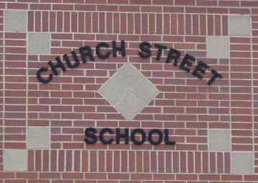
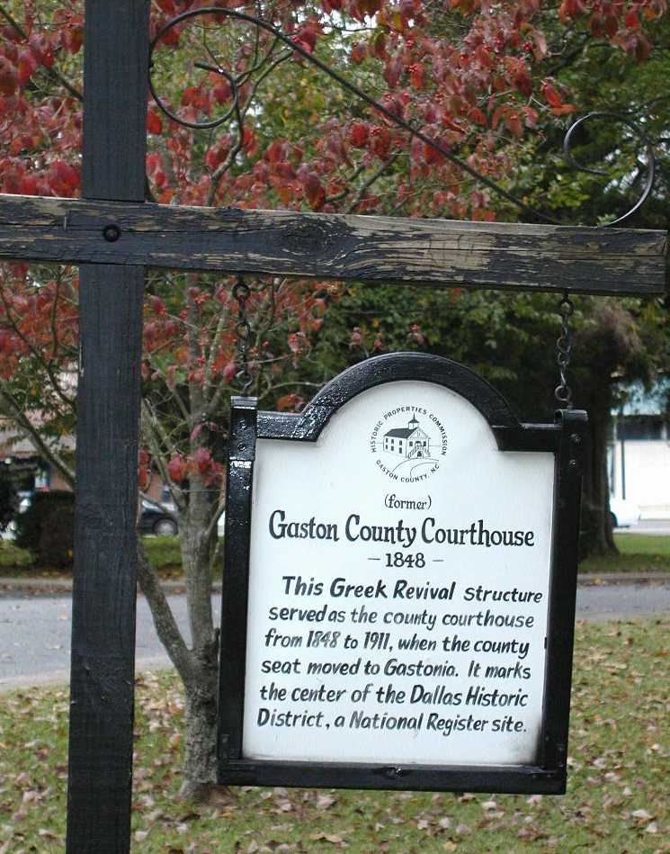

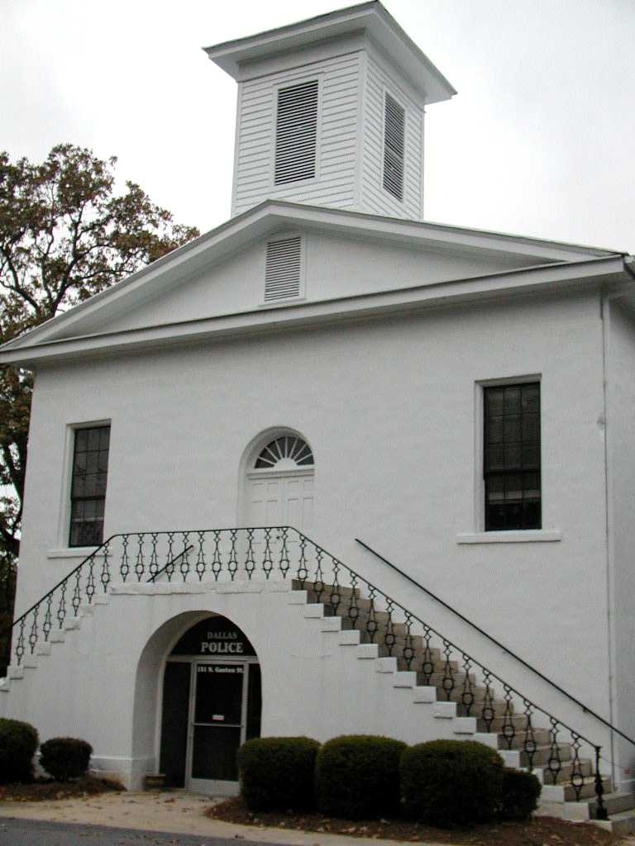
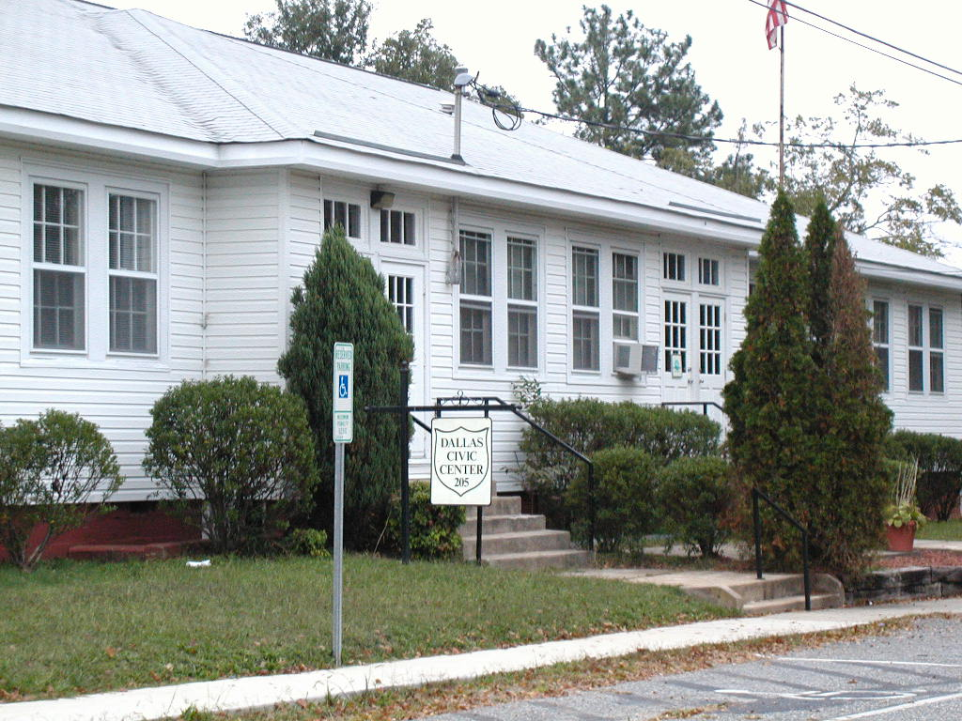

Land Use Plan

Gaston County, North Carolina
Adopted October14, 2003

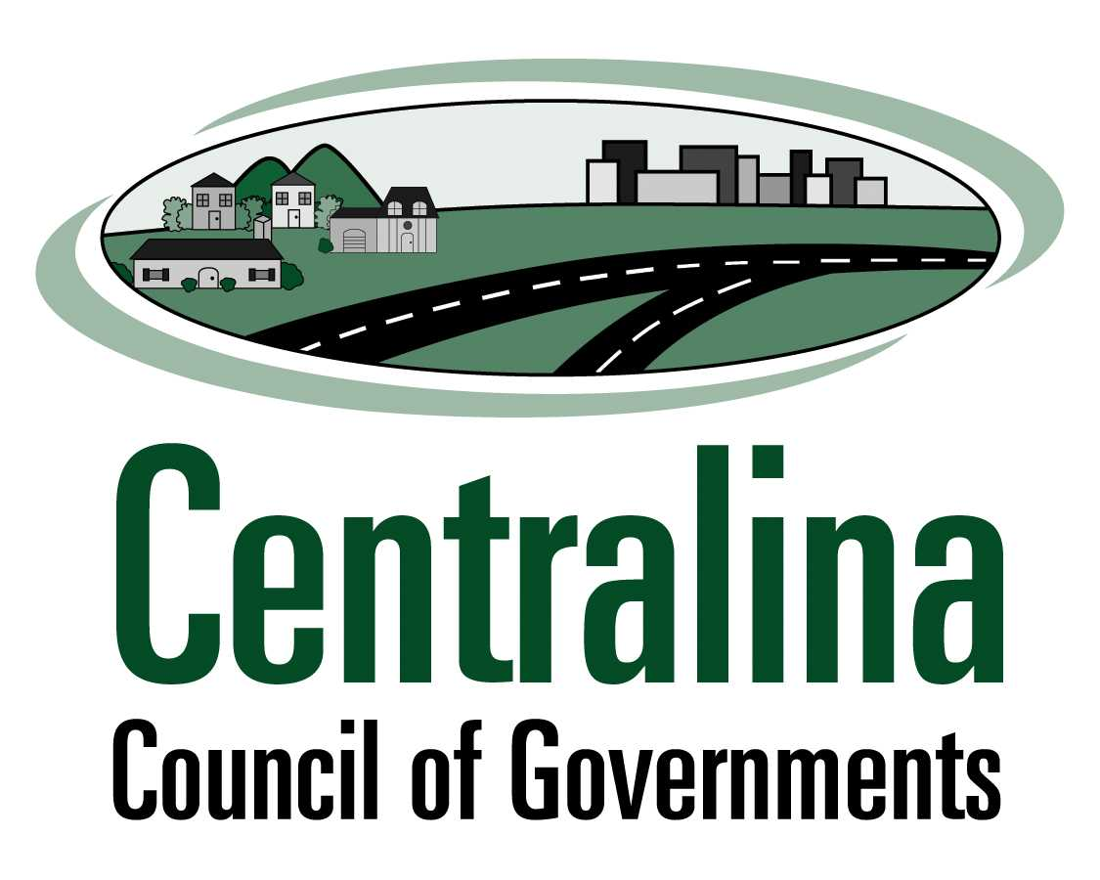

Prepared by:

Draft Dallas LUP/October 2003
The Town of Dallas first came into existence when the county was incorporated in 1846. The Courthouse Square was laid out on 75 acres acquired by the county for a price of $50. Government was the main economic engine of the town and brought with it a great influx of people and business. In 1863 the Town of Dallas (named for James K. Polk’s Vice-President George Mifflin Dallas) was incorporated as the first municipality in Gaston County.

The land that became Dallas was farmland, and a plan had to be enacted to assist in the building of a community. The original plan incorporated a “Public Square for the courthouse site, jail, and lots for churches, and lots for commercial and residential use.” Funds received by the sale of private lots were used to construct the county courthouse and jail. Though the streets were unpaved at the time, the roads were laid out in a grid pattern to promote connectivity and flow of traffic.

The business center of Gaston County, the Courthouse Square, bustled with extra life when the Court of Pleas and Quarter Sessions were held. Four times a year people would gather to conduct official business at the courthouse. During the Civil War, the square became the place to muster troops. The troops would then be marched to Brevard Station to board the trains to carry them to battle. While there were some skirmishes in the region, Gaston County was safe from major battles. Union troops were seen on the square during the Reconstruction Era when Gaston County, like other southern counties, experienced the end of one way of life and the beginning of another.

In the late nineteenth century, the textile industry brought rapid growth to Gaston County. Much of the growth was concentrated near the railroad intersection called Gaston Station. As that tiny spot grew into a city, the focus of population and power moved out of Dallas, and in 1911 the County seat was moved to Gastonia.

Although Dallas is no longer the center of activity for Gaston County, it retains a strong sense of history and community. Dallas is known for its historic center, its safe and walkable neighborhoods, and its small-town charm and quality of life. Although the Town recognizes the need for growth and quality development, it also understands the importance of preserving its history and maintaining quality of life for future generations. Proactive planning is therefore of major importance to the community.

In January 2003, the Town of Dallas and Centralina Council of Governments (CCOG) conducted a “Community Preference Survey” and public forum at the Dallas Civic Center. Approximately 70 people from the community came together to discuss the future of Dallas. During the next few months, CCOG met with Town staff and the Land Use Plan Steering Committee to draft a future land use map for the Town, as well as a series of goals and strategies for attaining those goals. At the same time, a group from the University of North Carolina at Charlotte (UNCC) Master of Public Administration Program was developing a “Strategic Plan for Economic Development Growth and Redevelopment” for the Town. This document reflects the sentiments expressed at the community forum and subsequent meetings and also takes into account the suggestions of the UNCC document. This document contains both goals and recommendations (and specific actions, where applicable) and a future land use map that should serve as a guide for growth and development in the Town of Dallas for the next ten years.

Goals and Recommendations
Land Use Goals:
- To maintain and promote a vibrant and healthy downtown for a variety of retail, commercial, residential, social, cultural, and institutional uses with sufficient parking areas.
- To maintain downtown Dallas as the community’s focal point.
- To plan for aesthetically pleasing and pedestrian friendly commercial corridors outside of the downtown area.
- To preserve the existing rail corridor and to redevelop the area while still retaining its historic character.
- To ensure that new residential development is in keeping with the traditional neighborhood development in Dallas.
- To continue to provide a mixture of housing choices in a manner that complements the Town’s character.
- To maintain a buffer of open space between Dallas and surrounding areas (Gastonia and the County).
- To allow for further development of both office and industrial sites within the community.

Recommendations:

- Ensure that the scale and design of commercial development, especially along Dallas-Cherryville Highway, New Hope Road and the old 321 corridor, is consistent with the unique small-town character of Dallas.

ACTION: Adopt a highway corridor overlay-zoning district. The district regulations should include requirements for:

- Street tree planting
- Parking lot planting
- Access management
- Rear access service roads
- Parking in the rear (bringing building facades to the street)
- Decorative lighting
- Developer responsibility for abandoned structures
- Sidewalks
- Underground utilities
- Architectural guidelines

- Ensure that land uses abutting residential development are compatible with the scale, intensity and overall character of existing and planned neighborhoods.

ACTION

Amend the Zoning Ordinance text to mandate a conditional use permit for certain commercial uses that lie adjacent to residential uses.

- Concentrate multi-family uses in specific areas throughout the community. Ensure that the design of these facilities is compatible with the neighborhoods adjacent to them.

ACTION

Amend the zoning ordinance to make multi-family development (particularly townhomes) a conditional use in the certain zoning districts. Include criteria for open space, connectivity and pedestrian accessibility.

- Allow manufactured housing in Dallas only within subdivisions in Residential (R) zoning districts. Augment appearance criteria to require permanent masonry foundations on all manufactured homes within the Town’s planning jurisdiction.

ACTION

Eliminate provisions for manufactured home parks. Add appearance criteria for manufactured homes on individual lots.

- Provide for alternative smaller lot sizes to promote the preservation of open space in the community.

ACTION

Amend the Zoning Ordinance text to allow for open space developments in areas of the Town that are served by public water and sewer. Minimum lot sizes can be reduced in such areas; open space would be preserved.

- Utilize parallel conditional use zoning districts to further ensure that future developments are built to the standards of the Ordinance and the expectations of the Town Council. Having a parcel rezoned to such a district would tie a specific development proposal to that parcel. Thus, the Town would be assured that a specific approved proposal, and nothing else, would be built on that lot.

- The area surrounding the rail corridor should become a redevelopment area and should include adaptive reuse of existing buildings. Possibilities include museums, restaurants and other commercial uses. The primary concern is that the historic character of the area be maintained.

ACTION

Develop a small area plan for the rail corridor.

- Encourage the development of office and industrial uses at well-planned locations throughout the community.

ACTION

Amend the Zoning Ordinance to distinguish between light and heavy industrial uses. Require a conditional use permit for heavy industrial uses. Small scale/light industrial uses should have no more than 20 employees and encompass no more than 20,000 square feet. The uses should not place a heavy burden on public infrastructure or the natural environment and should have relatively few off-site impacts.

- Consider requiring a conditional use permit for all “fast food” restaurants.

- Consider land use descriptions shown in Appendix A and the Future Land Use Map shown in Appendix B when making zoning and development decisions.

Community Image and Historic Preservation Goals:
- To maintain and enhance the Town’s aesthetic qualities and physical character.
- To improve upon the pedestrian realm that already exists throughout the community.
- To maintain downtown Dallas as the historic center of the Town.
- Continue to pursue historic district designation for downtown Dallas.

ACTION

Follow through with a survey of the downtown area.

- Explore the possibility of creating a “community node” around the Dallas High School. The area could contain:

- Community garden
- Gymnasium
- Citizens center
- Park
- Playground
- Soccer field
- Offices for police, fire and rescue, and parks recreation
- A redesigned street layout

- Ensure proper maintenance of the older neighborhoods surrounding downtown.

ACTION

Per the recommendation of the UNCC study, the Town should pursue a Community Development Block Grant for code enforcement and regulation in deteriorated and deteriorating residential areas. (Please see the UNCC study for further detail.)

- Ensure proper upkeep of downtown storefronts.

ACTION

Per the recommendation of the UNCC study, the Town should pursue a Community Development Block grant for downtown revitalization activities such as storefront renovation.

- Distinguish the Town of Dallas from surrounding areas by establishing “gateways” into the community.

ACTION

Install “Welcome to Dallas” signs at strategic locations in town. The sign areas should include plantings and decorative lighting.

The first sign should be installed at the intersection of Main Street and Lower Dallas Highway. This is the corridor that most residents travel. The second sign should be as close to the Highway 321 corridor as possible. Maybe we could rent space to business to advertise along with plantings and trees.

- Encourage the preservation and renovation of older homes and structures in the community to preserve a sense of history.

ACTION

Encourage Gaston County to adopt North Carolina’s new Rehabilitation Code. The code provides a framework wherein code requirements on renovations of existing structures gradually increase as a project’s scope of work increases. The code is more flexible for historic building projects and friendlier to small rehab projects, encouraging rather than discouraging the upgrading of buildings.

- Improve parking in the downtown area.

ACTION

Although on-street parking is an important element in a pedestrian friendly downtown, the Town should consider eliminating truck parking along Trade Street. In addition, a public parking lot should be considered behind Town Hall.

Public Facilities and Transportation Goals:
- To ensure that the park and recreation needs of Dallas residents are met with adequate recreational facilities in the area.
- To provide safe and convenient mobility for Dallas residents of all ages.
Recommendations
- Provide for future connectivity within the town.

ACTION

Change subdivision ordinance to limit cul-de-sacs and require stub out streets to be connected to new subdivisions as they develop.
- Improve existing park locations. Suggested improvements include:

- Benches
- Lighting
- Paved and landscaped parking
- Outdoor basketball courts
- Horseshoe pits
- Drinking fountains
- Screened port-a-johns
- Bike trails

- Continue to work with the Transportation Advisory Committee (TAC) to ensure that transportation improvements are in the Town’s best interests.

ACTION

Currently, the New Hope Road widening project has been funded and is under construction from NC 7 to Robinson Clemmer Road. The portion from Robinson Clemmer to the railroad tracks in Dallas is unfunded with no current timetable. It is essential to work with the TAC to make requests on this portion.

- Improve the residential parking situation on older streets. Cars are often parked on both sides of the street, making the roads nearly impassible.

ACTION

Dallas currently owns the right of way behind lots in older residential neighborhoods. Consider reclaiming the right of way to build alleyways for parking. Consider revising the parking ordinance.

- Once the rail corridor becomes inactive, consider converting it to a greenway.

Appendix A
Land Use Classifications

Central Business District

This planning area consists of the historic center of commercial and governmental activity in Dallas and contains buildings with many unique historical and architectural features. Future land uses (including new uses and redevelopment of existing structures) are encouraged so as to accentuate and enhance the area’s unique atmosphere. Future mixed-use commercial and residential development is encouraged as a means of enhancing the area’s vitality. Land use policies and practices should be devised so as to promote pedestrian accessibility while alleviating traffic concerns. Boundaries of the area should follow the designated historic district. Uses should be scaled to fit the area (e.g., neighborhood drugstores, art shops, and antique shops). Removal of structures of historical significance is discouraged.

Office/Small-Scale Industrial

This planning area is suitable for offices (including medical and lawyers offices). Small-scale industrial uses should have no more than 20 employees and encompass no more than 20,000 square feet. These uses would not place a heavy burden on public infrastructure or the natural environment and should have relatively few off-site impacts. Larger scale industrial development may be allowed in this area but only with the issuance of a conditional use permit.

Residential Agricultural

These areas consist of large existing tracts that should keep their agricultural uses or be developed in a way that compliments agricultural uses (i.e., tractor repair shops, farmers markets, horse stables). The open space serves as a buffer between Dallas and Gastonia and also the surrounding County. “Conservation subdivisions” that retain a significant amount of open space may be appropriate in these areas.

Neighborhood and Community Business
These areas are located where appropriate to serve existing and future residential development. These developments are relatively small in scale and include uses that provide customers with everyday retail goods and services. “Big-box” stores (larger, single unit stores – other than grocery stores – either on individual lots or located within shopping centers) are not generally suitable for such areas. These areas should be designed to blend in with adjacent residential areas. Where practical, connectivity with adjacent residential areas is encouraged. Such areas should be pedestrian-friendly and be developed to give patrons pedestrian mobility both leading to and within the shopping area.

General Business

General business areas are typically located along major thoroughfares. These areas contain commercial uses that are broader in scope than those in the Neighborhood and Community Business districts. Uses may serve markets beyond Dallas and may require outdoor storage. Big box development may be possible in the General Business district, but only with the issuance of a Conditional Use Permit (with attention paid to aesthetics).

Traditional Neighborhood, Higher Density

These planning areas consist of single-family uses on smaller to medium size parcels in older established portions of the community. Such areas do not usually encompass significant areas of undeveloped land. The preservation of neighborhood character is a high priority in these areas, and they should be protected from encroachment of incompatible business and industrial uses.

Traditional Neighborhood, Lower Density

These areas are similar in nature to the Traditional Neighborhood, Higher Density. Lot sizes, however, tend to be larger.

New Residential

These areas are primarily single-family in character but are on larger lots than in the Traditional Neighborhood areas. Most new single-family residential development is likely to occur in these planning areas. Thus, proactive planning is strongly encouraged. This includes ensuring that all developments contain sidewalks on both sides of the road and that where practical, connectivity is provided to nearby Neighborhood and Community Business areas. Multi-family developments, especially townhomes, may be allowed in this district as a conditional use. The developments would preferably be clustered so as to preserve open space and heighten pedestrian accessibility.

Redevelopment Zone

This area abuts the existing rail corridor south of Main Street and has historically been zoned for industrial use. The area is largely comprised of residential uses with commercial and industrial building scattered throughout. The Town is strongly encouraged to create a “small area plan” for the Redevelopment Zone to make specific recommendations for the corridor. Among the possibilities is to create a “non-residential redevelopment zone.” The primary concern is that this area keeps its historic flavor. Mill structures should be retained, and uses should include restaurants, museums, offices, and commercial uses in existing buildings.

Institutional

These planning areas are suitable for existing and expanded institutional uses and associated office developments. These areas are generally compatible with adjoining residential uses and can serve as transitional areas between more traditional retail and commercial areas and residential uses. In order to retain the residential character of the area, offices are encouraged to utilize existing residential structures.

